**Lab Practical**

**Student Name: Yash Gupta           UID: 20BCS5009**

**Branch: CSE     Section: 709 - A**

**Subject Name: Computer Networks Lab**

**Subject Code: 20CSP-257**

*Types of Transmission Media: -*

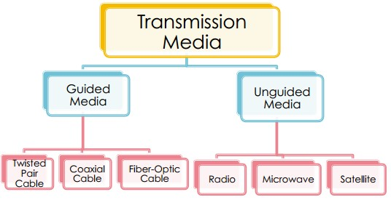

**1. Guided Transmission Media**

# • Twisted pair :-

Is a physical media made up of a pair of cables twisted with each other. A twisted pair cable is cheap as compared to other transmission media. Installation of the twisted pair cable is easy, and it is a lightweight cable.

**a. Twisted Pair are of two types :-**

1. **Unshielded Twisted Pair :**

An unshielded twisted pair is widely used in telecommunication. It is cheap. Installation of unshielded twisted pair is easy and it can be used for high-speed LAN.

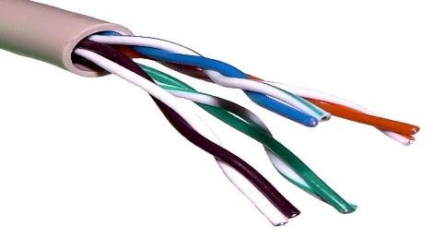

1. **Shielded Twisted Pair :**

A shielded twisted pair is a cable that contains the mesh surrounding the wire that allows the higher transmission rate. It has higher capacity as compared to unshielded twisted pair cable. It is shielded that provides the higher data transmission rate.

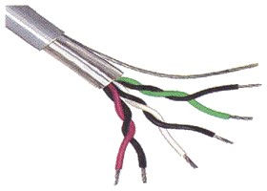

* **Coaxial Cable :-**

The name of the cable is coaxial as it contains two conductors parallel to each other. It has high frequency as compared to Twisted pair cable.

The inner conductor of the coaxial cable is made up of copper and the outer conductor is made up of copper mesh. The middle core is made up of non-conductive cover that separates the inner conductor from the outer conductor.

The middle core is responsible for the data transferring where as the copper mesh prevents from EMI.

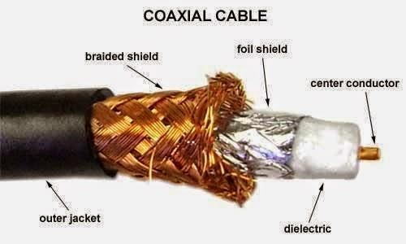

* 1. Baseband transmission :-

It is defined as the process of transmitting a single signal at high speed.

* 1. Broadband transmission :-

It is defined as the process of transmitting multiple signal simultaneously.

* Fibre Optic :-

It uses electrical signals for communication by sending the data in pulses of light.

The plastic coating protects the optical fibre from heat, cold, electromagnetic induction from other types of wires. It proves faster data transfer than copper wires.

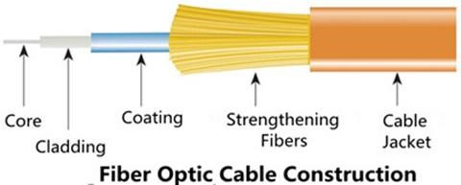

* + 1. Core :-

The optical fibre consists of a narrow strand of glass or plastic known as a core. A core is a light transmission area of the fibre. The more the area of the core, the more light will be transmitted into the fibre.

* + 1. Cladding :-

The concentric layer of glass is known as cladding. The main functionality of the cladding is to provide the lower refractive index at the core interface as to cause the reflection within the core so that the light waves are transmitted through the fibre.

* + 1. Jacket :-

The protective coating consisting of plastic is known as a jacket. The main purpose of a jacket is to preserve the fibre strength, absorb shock and extra fibre protection.

**2. Unguided Transmission Media**

1. **Radio Waves :-**

Radio waves are electromagnetic waves that are transported in all the direction of free space it is Omnidirectional.

The range of radio frequency is from 3Khz to 1Khz.

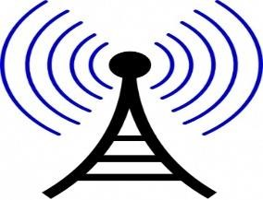

1. Microwaves [:-](https://creativecommons.org/licenses/by-sa/3.0/)

Microwaves are the electromagnetic waves having the frequency in the range of 1GHz to 1000GHz.

Microwaves are unit direction as this sending and receiving antenna is to be aligned the waves sent by sending antennas are narrowly focused.

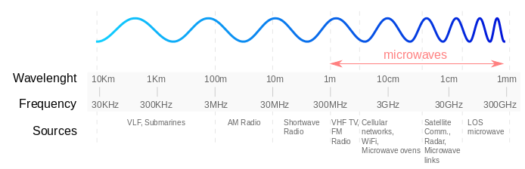

1. Infrared :-

Infrared transmission is a wireless technology used for communication over short range, the frequency ranges from 300GHz to 400GHz.

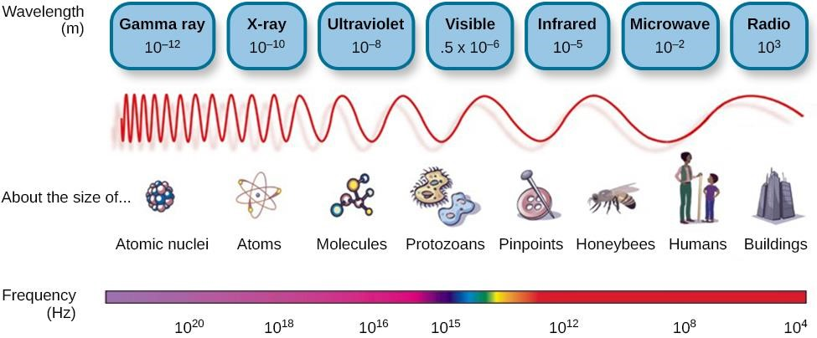

*Steps to create the connector to make an Ethernet connection possible.*

1. Use your cable shippers at about 1-2 inches from the end off the cable to remove outer jacket.
2. Untwist their twisted pair wires all the way back to the jacket this can be done just like a regular twist-tie on a loaf of bread but with four of them of different colors.
3. Align the twisted wires in the order necessary for your needs.
4. Cut the extra wire. Once you are untwisted the wires you will have surplus amount of copper wiring left. Use the wire-cutting scissors to cut unneeded wire.
5. Push the remaining bars into the RJ45 head according to color code. Be careful do not bend the wire while pushing them in or you run the risk of creating a bad cable.
6. Where’s the connector inside the crimping tool and squeeze the crimper all the way down.
7. Repeat steps one to six for the other end of the cable.
8. To make sure you are successful terminated each end of the cable using cable tester to test each pin. When you are older the connector should be like this.

